|  |
| --- |
| Serial No: |
| **Sessional I** |
| **Total Time: 60 minutes** |
| **Total Marks: 40** |
| ________________  Signature of Invigilator |

|  |
| --- |
| **CS301-Theory of Automata** |
| Tuesday, Sept 15, 2015 |
| **Course Instructor** |
| Dr. Aftab Maroof, Ms. Mehreen Alam |

|  |
| --- |
| **_____________________________________________ _____________________**  Student Name Roll No Section Signature |

## DO NOT OPEN THE QUESTION BOOK OR START UNTIL INSTRUCTED.

**Instructions:**

1. Understanding the question paper is also part of the exam, so do not ask any clarification.
2. The question paper is printed on both sides of the pages.
3. Attempt all questions on the same sheets/pages and within the space provided with each question. You may lose marks if you write in extra space.
4. Make sure that this question paper contains seven **(07)** pages including title page. Be brief, smart and efficient!
5. Use permanent ink pens only. Any part done using soft pencil will not be marked and cannot be claimed for rechecking.

|  |  |  |  |  |  |  |  |
| --- | --- | --- | --- | --- | --- | --- | --- |
| Question | 1 | 2 | 3 | 4 | 5 | 6 | **Total** |
| **Marks Obtained** |  |  |  |  |  |  |  |
| **Total**  **Marks** | 5 | 5 | 5 | 5 | 5 | 15 | **40** |

**Vetted By: _____________________________Vetter Signature: _____________________**

**Q1. [5 pts]Give recursive definition for the set POWERS-OF-THREE = {1, 3, 9, 27, 81,..}**

**Q2. [5 pts]Write regular expression for the language over the alphabet {a,b} that all words begin with zero or more b’s followed by any odd clumps of a’s and odd number of b’s.**

**Q3. [5 pts]Give the state diagram of an FA for the following language 10+(0+11)0*1 over the alphabet {0,1}**

**Q4. [5 pts]Convert the following TG to an RE using the algorithm studied. For full credit, show all the steps clearly. ∑ = {0,1,2}**

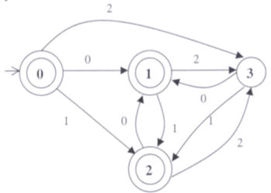

**Q5. [5 pts]Give state diagram of an NFA recognizing the language represented by the regular expression a+( a*b + ab )* over the alphabet {a,b}.**

Q6. [7+5+3] = 10pts]Consider the following NFA. Use the algorithms studied and show all steps to get full credit.

1. Convert this NFA to the corresponding DFA. Show the resultant transition table and the state diagram.
2. Minimize this DFA. Show the resultant state diagram.
3. Convert the minimized DFA in to RE.

